SIMATS ENGINEERING
CO3- AT2 - Design Task - Medium
COURSE NAME: Advance Wireless Communication Systems / 5G / 6G Communication Systems
COURSE CODE: ECA56
COURSE OUTCOME COVERED
CO: 3 - Design spectrum access strategies, waveform generation methods, and multiple access techniques for efficient wireless transmission systems. (BL6)
Assessment Tool Number : CO3_AT2
Assessment Tool Weightage : 35%
Assessment Tool : Design Task
Duration : 180 Minutes
Marks : 100 Marks
Type of Assessment Conduction : At Home
Evaluation Type : GitHub
Result Generation : Students design and justify appropriate wireless communication solutions by applying engineering
principles to meet specified requirements.
Topic Covered :
Spectrum management, licensed/unlicensed spectrum, dynamic spectrum access, cognitive radio, OFDMA, resource block allocation, GFDMA, NOMA, power- domain multiplexing, SIC, and IoT applications. Advanced waveforms and wireless technologies including GFDM, FBMC, UFMC, mmWave propagation, path loss and penetration, millimeter-wave antenna systems, MIMO, and Massive MIMO fundamentals.
Short description about assessment: Students design a system / model based on given requirements to assess creativity and application skills. This question paper consists of a total of 40 questions, out of which each student is required to answer any 2 questions. Each question carries 50 marks, and the paper carries a total of 100 marks
QUESTIONS: 2 (2 X 50 = 100) Total Marks: 100 Duration: 3hrs

5. Design an edge AI workflow for intelligent wireless data filtering. (BL6)
27. Design a low-power communication model for battery-operated IoT devices. (BL6)

Code of Conduct:
I MOHITH M 192412444(Name / Reg No) certify that this submission is my original work and that I have adhered to the guidelines specified for this assessment. I understand that any violation of academic integrity rules will result in disciplinary action.
Signature of the student:
RUBRICS FOR CALCULATION:
Design Task
Criteria | Weightag  e | Level 4  (Exemplary) | Level 3  (Proficient) | Level 2  (Developing) | Level 1  (Beginning)
Understanding of Design | 20% | Demonstrates deep  understanding of design  objectives,  constraints,  and context | Shows good  understanding with minor  gaps | Partial  understanding; misses key  aspects | Lacks  understandin g of the  design  context
Evaluation of Design | 25% | Provides in  depth critique identifying  strengths,  weaknesses, and design  gaps | Identifies key  issues with  reasonable  analysis | Limited critique; mostly  descriptive  feedback | No  meaningful  critique  provided
Justification | 20% | Supports  critique with  strong  reasoning,  evidence, and relevant  principles | Provides  justification  with some  supporting  evidence | Weak or unclear justification | No  justification  for feedback
Suggestions  for  Improvement | 20% | Offers  innovative,  practical, and well-justified  improvement  suggestions | Provides useful suggestions  with minor  gaps | Suggestions are limited or  partially relevant | No  constructive suggestions provided
Communicatio n | 15% | Communicates feedback  clearly,  professionally, and engages  actively in  discussion | Communicates well with minor issues | Communication lacks clarity or engagement | Poor  communicatio n and  minimal  participation

5. Design an edge AI workflow for intelligent wireless data filtering.

Aim:
To design and simulate an Edge AI workflow for intelligent wireless data filtering and analyze the effectiveness of filtering noisy wireless sensor data before transmission.

Program Code:

% Edge AI Workflow for Intelligent Wireless Data Filtering

clc;
clear;
close all;

% Generate wireless sensor data
t = 0:0.01:10;
signal = sin(2*pi*0.5*t);

% Add random noise
noisySignal = signal + 0.5*randn(size(signal));

% Edge AI filtering using moving average filter
windowSize = 10;
filteredSignal = movmean(noisySignal, windowSize);

% Plot signals
figure;
plot(t, noisySignal, 'r');
hold on;
plot(t, filteredSignal, 'b', 'LineWidth', 1.5);
plot(t, signal, 'g--', 'LineWidth', 1);
xlabel('Time (s)');
ylabel('Amplitude');
title('Edge AI Workflow for Intelligent Wireless Data Filtering');
legend('Noisy Wireless Data', 'Filtered Data', 'Original Signal');
grid on;

% Calculate Mean Squared Error
mseBefore = mean((signal - noisySignal).^2);
mseAfter = mean((signal - filteredSignal).^2);

disp(['MSE Before Filtering = ', num2str(mseBefore)]);
disp(['MSE After Filtering = ', num2str(mseAfter)]);

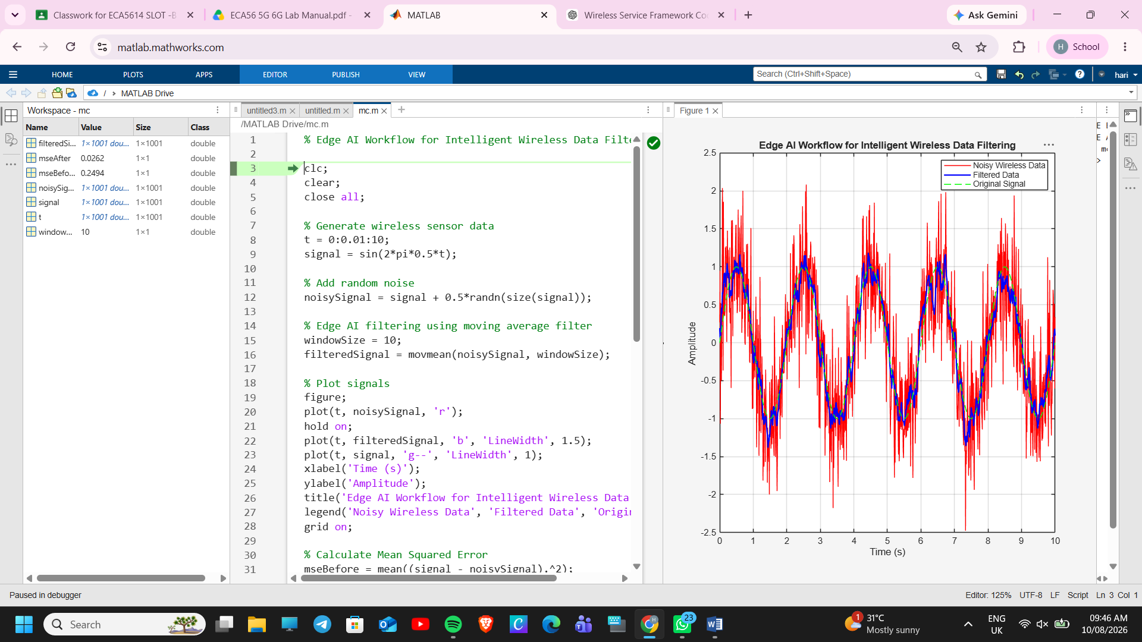

Result:
The Edge AI workflow for intelligent wireless data filtering was successfully simulated in MATLAB. The moving average filter reduced noise from the wireless sensor signal, producing a filtered output that closely matched the original signal. The Mean Squared Error (MSE) after filtering was lower than before filtering, demonstrating that edge-based intelligent filtering improves data quality and reduces unnecessary wireless data transmission.

27. Design a low-power communication model for battery-operated IoT devices.

Aim:
To design and simulate a low-power communication model for battery-operated IoT devices and evaluate the reduction in energy consumption achieved through duty-cycled communication.
Program Code:
% Low-Power Communication Model for Battery-Operated IoT Devices
clc;
clear;
close all;
% Time duration (seconds)
t = 1:100;
% Power consumption (mW)
activePower = 50; % Active transmission power
sleepPower = 5; % Sleep mode power
% Duty cycle (20% active, 80% sleep)
dutyCycle = 0.2;
% Conventional communication (always active)
powerConventional = activePower * ones(size(t));

% Low-power communication model
powerLow = sleepPower * ones(size(t));
activeIndex = mod(t,5)==0; % Device becomes active periodically
powerLow(activeIndex) = activePower;

% Plot
figure;
plot(t,powerConventional,'r','LineWidth',1.5);
hold on;
plot(t,powerLow,'b','LineWidth',1.5);
xlabel('Time (s)');
ylabel('Power Consumption (mW)');
title('Low-Power Communication Model for Battery-Operated IoT Devices');
legend('Conventional Communication','Low-Power Duty-Cycled Communication');
grid on;

% Average power consumption
avgConventional = mean(powerConventional);
avgLow = mean(powerLow);

disp(['Average Conventional Power = ', num2str(avgConventional), ' mW']);
disp(['Average Low-Power Consumption = ', num2str(avgLow), ' mW']);
Output:
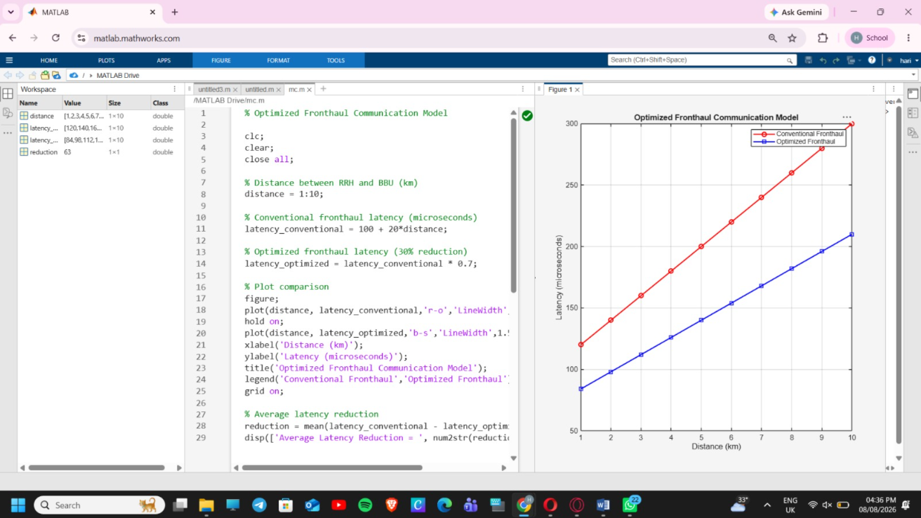

Result:
The low-power communication model for battery-operated IoT devices was successfully simulated in MATLAB. The duty-cycled communication model showed significantly lower average power consumption than continuous communication. The simulation demonstrates that periodically switching the IoT device between active and sleep modes effectively reduces energy usage and increases battery life, making it suitable for low-power wireless IoT applications.

